Consulate General of India
Atlanta

PRESS RELEASE

On the occasion of 142nd Birth Anniversary
of
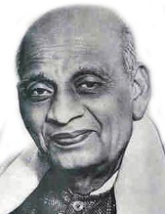
Sardar Vallabhbhai Patel

Consulate General of India, Atlanta
cordially invites you for celebrations

at

Consulate General of India, Atlanta
5549 Glenridge Drive NE, Atlanta, Georgia – 30342
on
Tuesday 31 October 2017
1830 – 2030 hrs
******

